Crashing Boxes

DESCRIPTION:
You are stacking some boxes containing gold weights on top of each other. If a box contains more weight than the box below it, it will crash downwards and combine their weights. e.g. If we stack [2] on top of [1], it will crash downwards and become a single box of weight [3]. Given an array of arrays, return the bottom row (i.e. the last array) after all crashings are complete.

SOLUTION:
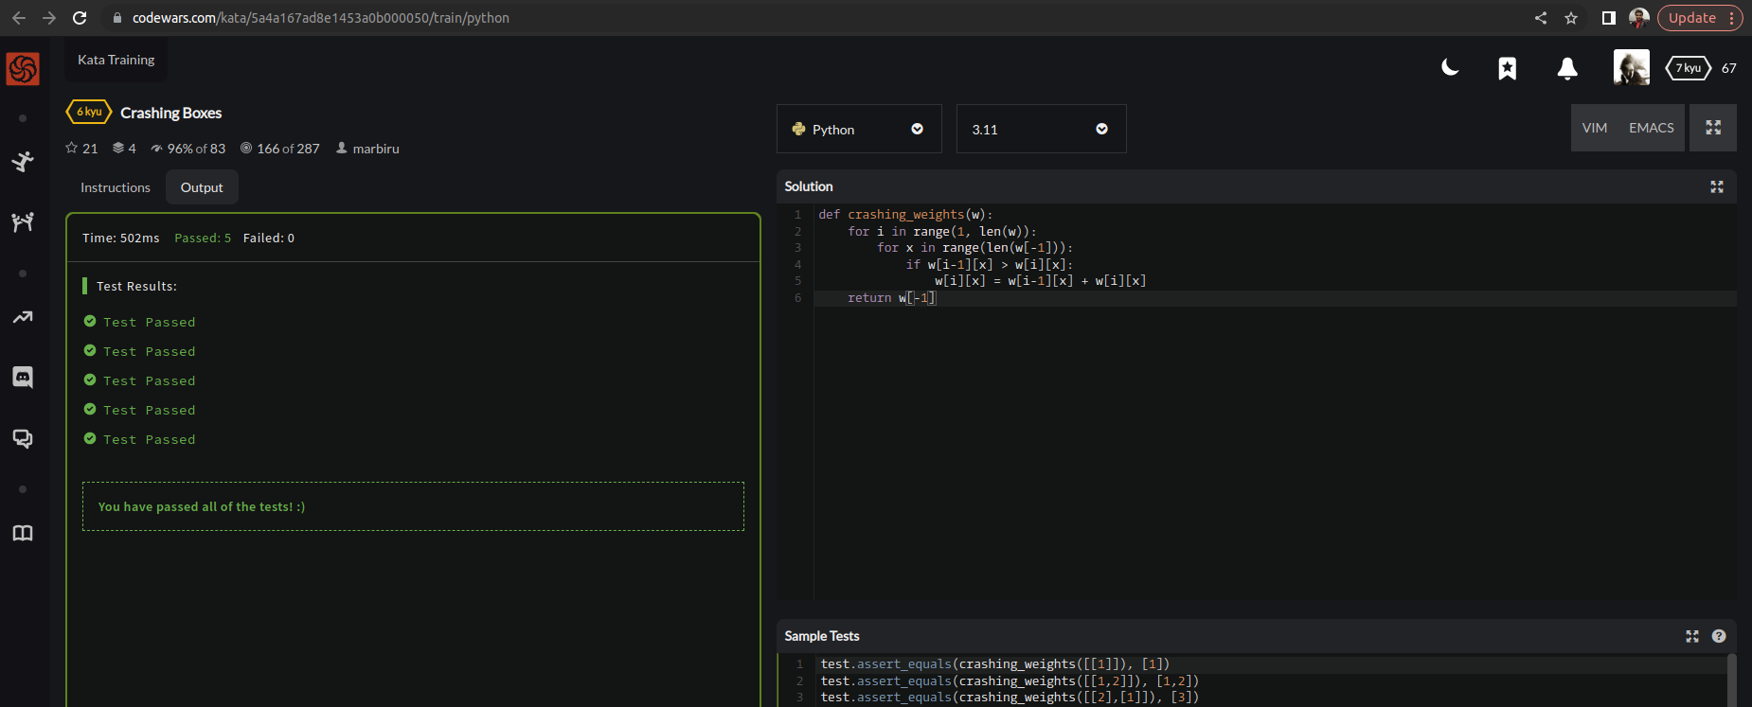

EXPLANATION:
This Python function crashing_weights simulates a process of adding weights from the top to the bottom of a matrix. If a weight on a higher row is greater than the weight below it, the higher weight is replaced with the sum of the two weights. The function then returns the final row of the matrix after all such replacements have been made.

